|  |
| --- |
| Circle Language Spec: Commands |

## Inactive Clauses in a Command Definition in a Diagram

This article demonstrates a situation of command objects.

This article illustrates how inactive clauses in a command definition look in a diagram.

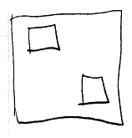

The larger square is a command definition. The smaller squares inside the larger square are inactive clauses inside a command definition. Squares inside a square, that do not redirect, are inactive clauses.